Snowflake Architecture & Cache with Practical Examples

Explain in your own words the three main layers of Snowflake architecture.
Snowflake uses a 3-layer architecture that separates storage, compute, and services. This separation is what makes Snowflake scalable and efficient.
1. Cloud Services Layer
The brain of Snowflake.
Handles:
- Query parsing & optimization
- Metadata management
- Access control & security
- Transaction management
- Query coordination
2. Compute Layer (Virtual Warehouse)
Virtual Warehouses provide compute power to run queries.
They do not store data, only process it.
Multiple warehouses can access the same data without conflict.
Can be scaled up or down and started/stopped independently.
3. Storage Layer
Stores all data (tables, stages, micro-partitions) in cloud storage like AWS S3, Azure Blob, or GCP.
Data is automatically compressed, encrypted, and optimized by Snowflake.
Users do not manage files or partitions manually.
Practical:
Draw a simple diagram showing Storage, Compute (Virtual Warehouse), and Cloud Services.
Explain what happens when you run a SELECT query.
1. Cloud Services Layer
- Parses the SQL query.
- Checks user permissions.
- Creates the query execution plan using metadata.
2. Compute Layer (Virtual Warehouse)
- The assigned warehouse starts (if not already running).
- It reads required micro-partitions from storage.
- Applies filters, joins, aggregations.
3. Storage Layer
- Returns only the required data blocks (micro-partitions).
- No full table scan if pruning is possible.
4. Results Returned
- Processed results are sent back to the user.
- Warehouse can auto-suspend after execution.

2. What is the role of the Storage layer in Snowflake?
The Storage Layer is responsible for persistently storing all data in Snowflake, independent of compute.
Key Roles of the Storage Layer
- Stores tables, views data, stages, and micro-partitions
- Data is:
  - Automatically compressed
  - Encrypted at rest
  - Stored in cloud object storage (S3 / Azure Blob / GCP)
- Manages micro-partitions for efficient query pruning
- Ensures data durability and availability
- Data remains unchanged and available even when compute (warehouse) is stopped
Practical:
Create a table and insert some data. Show how data remains stored even if the warehouse is suspended.
Created Table :
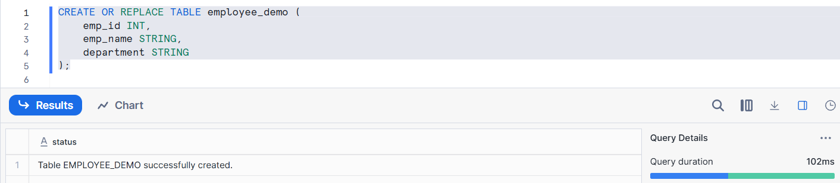
Inserted 3 records :
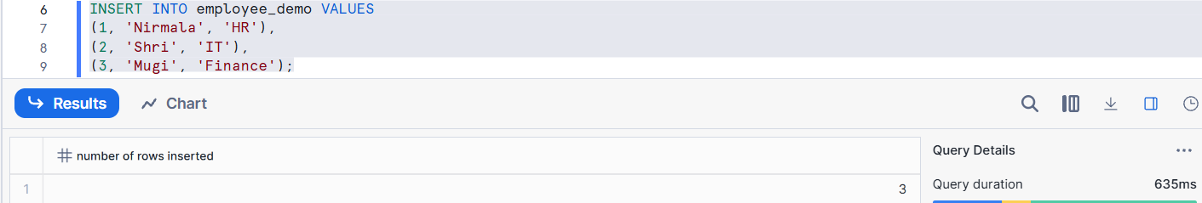
Querying :
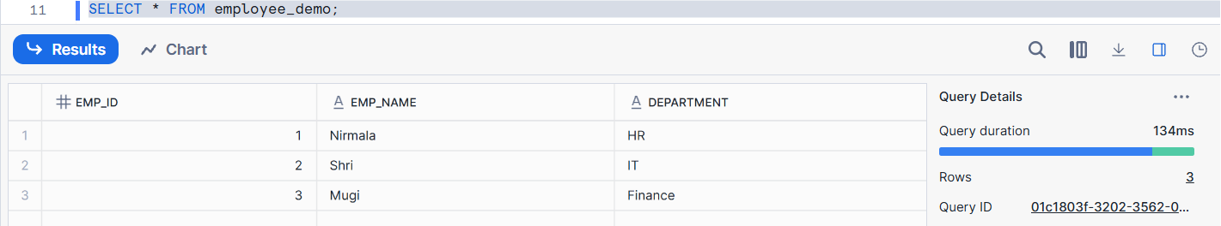
Suspend Warehouse :
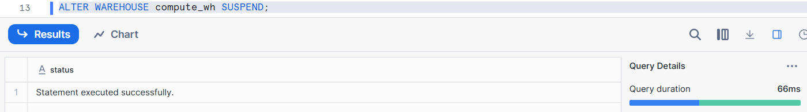
Resume Warehouse :
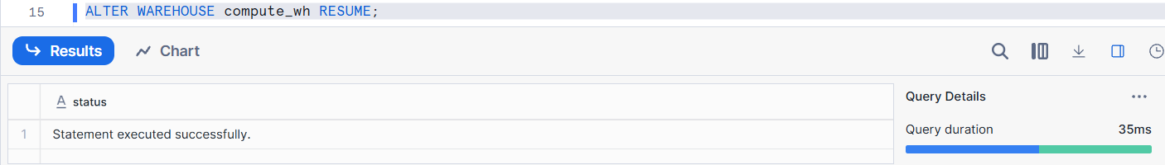
Resume Warehouse and Query Again :
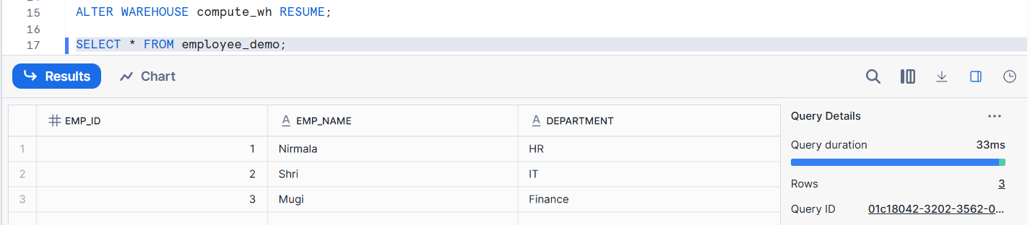

3. Describe what a Virtual Warehouse is in Snowflake.
A Virtual Warehouse is a compute resource in Snowflake that provides the processing power required to execute SQL queries.
Key Points:
- It does not store data (data is in the Storage layer).
- Used for:
  - SELECT queries
  - INSERT / UPDATE / DELETE
  - COPY INTO (data loading)
- Warehouses can be:
  - Started / Stopped (Suspend / Resume)
  - Resized (XS → S → M → L → XL)
- Multiple warehouses can query the same data simultaneously without blocking each other.
Practical:
Create a warehouse, run a query, then suspend the warehouse. Show how warehouse size affects query speed by resizing it.
Warehouse Creation :
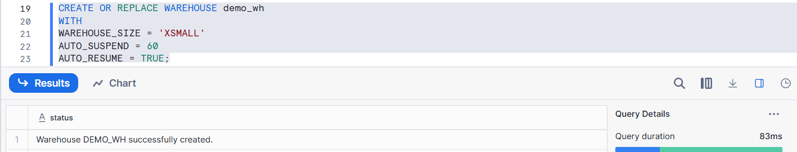
Query :
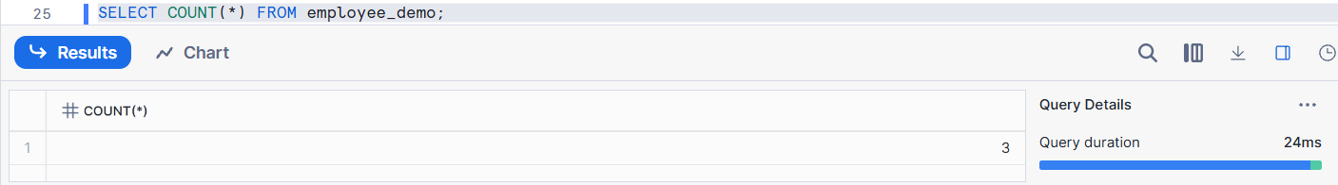
Resize the Warehouse Size :
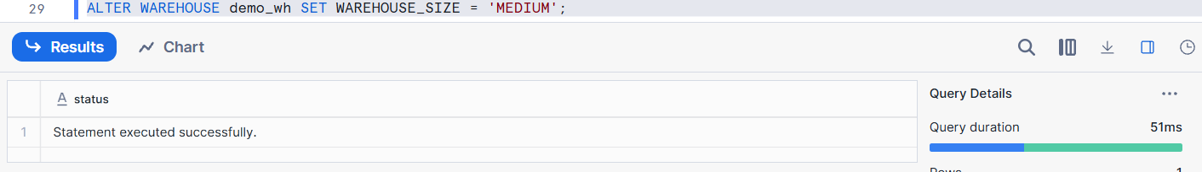
Query :
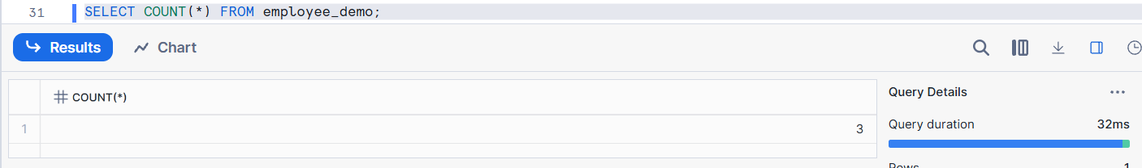

4. Explain micro-partitions and their importance.
Micro-partitions are small, automatically created blocks of data in Snowflake storage.
Each micro-partition typically stores 50–500 MB of compressed data.
Key Characteristics :
- Data is stored in columnar format
- Each micro-partition contains metadata such as:
  - Minimum value
  - Maximum value
  - Number of rows
- Metadata is stored in the Cloud Services layer
Importance:
1. Faster Query Performance Snowflake uses metadata (min/max values) to skip unnecessary micro-partitions.
2. No Manual Indexing No need to create indexes and Snowflake automatically optimizes data access
3. Reduced Data Scanning = Lower Cost Only relevant micro-partitions are scanned and Less compute usage → cost efficient
Practical:
Run a query with a filter (e.g., WHERE AMOUNT > 1000) and explain how Snowflake reads only relevant micro-partitions to speed up the query.
Query with filter:
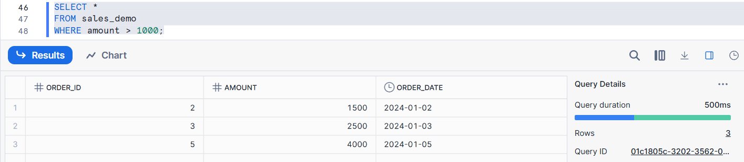
How it works :
1. Snowflake checks micro-partition metadata
2. It looks at MIN and MAX values for amount
3. Micro-partitions where:
MAX(amount) <= 1000 are skipped
4. Only micro-partitions that may contain values > 1000 are scanned

5. What is the Cloud Services layer?
The Cloud Services layer is the control and management layer of Snowflake.
It does not store data or execute queries, but it coordinates and manages everything.
Responsibilities of Cloud Services Layer :
1. User authentication (login verification)
2. Role-based access control (RBAC)
3. Query parsing and optimization
4. Metadata management
5. Transaction management
6. Query coordination
Practical:
Show a login process and role-based access in Snowflake. Explain how Cloud Services verify permissions before query execution.
Login Process :
Current Role :
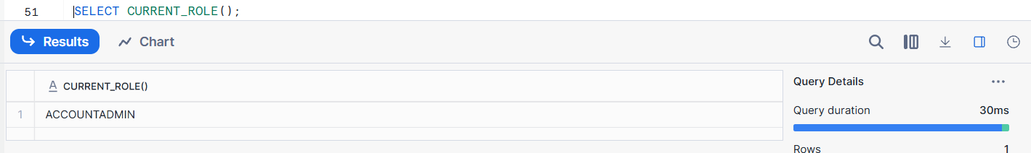
Create a role :
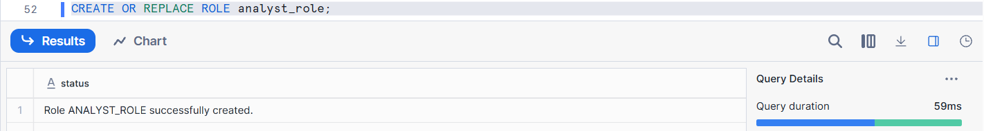
Grant Privileges :
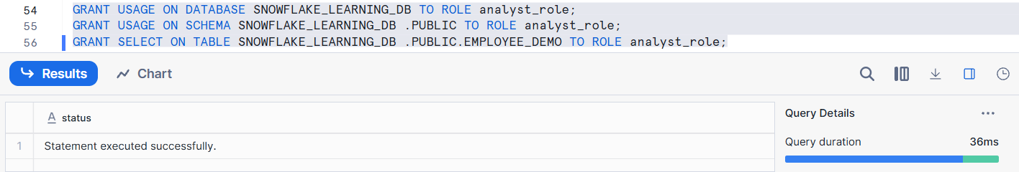
Assign to user :
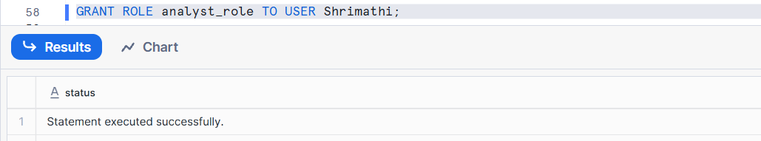
Query executes successfully → Permission verified by Cloud Services
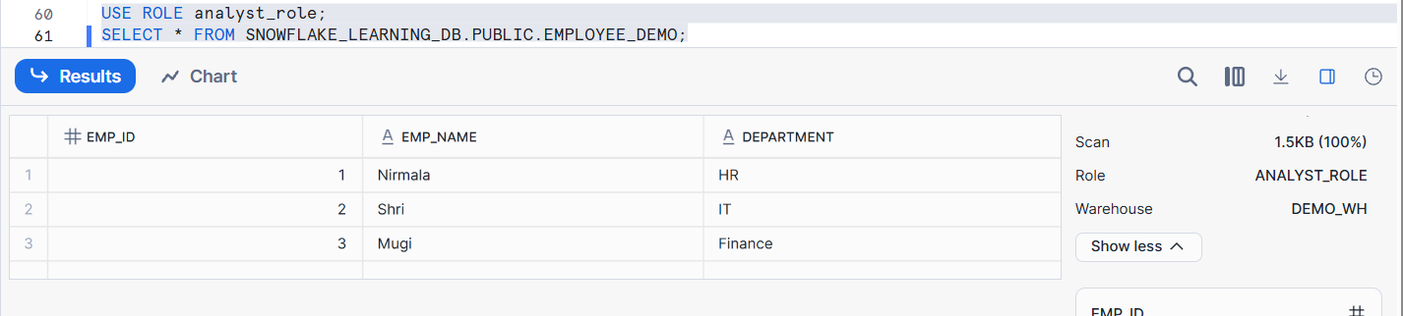

6. Name and describe the three types of cache Snowflake uses.
Snowflake uses three levels of caching to improve query performance and reduce cost.
1. Result Cache
Stores the final result of a query
Stored in Cloud Services layer
No warehouse compute is used when result cache is hit
2. Local Disk Cache
Stores raw data blocks (micro-partitions) on the local SSD of the warehouse
Used when result cache is not applicable
3. Remote (Cloud Storage) Cache
Data read directly from Snowflake Storage layer
Used when:
- Result cache is invalid
- Local disk cache is empty
Practical:
Run the same query twice and measure execution time to demonstrate Result Cache.
Restart warehouse and rerun query to explain Local Disk Cache.
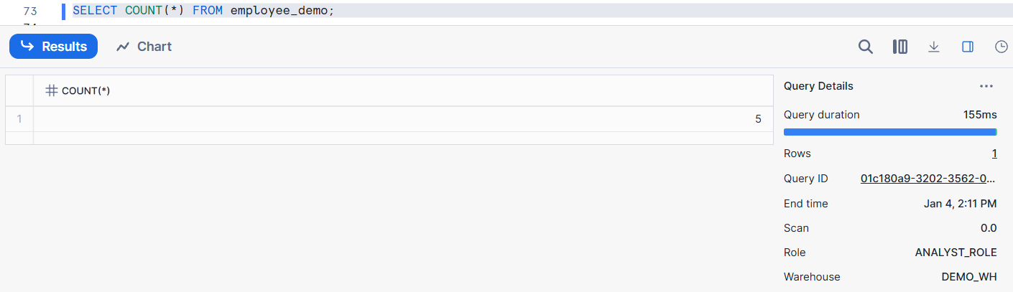
Run SAME Query Again and checked the query profile
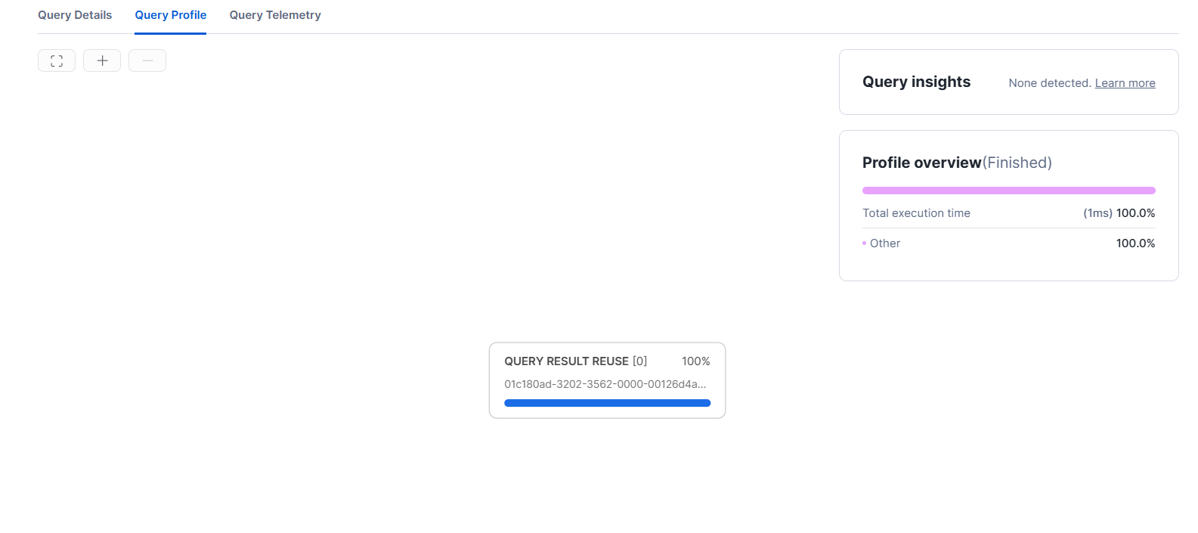
Suspend the Warehouse
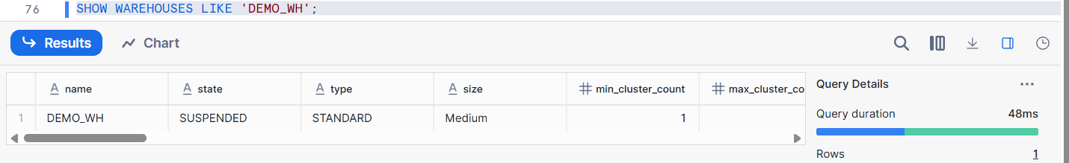
Resume the warehouse
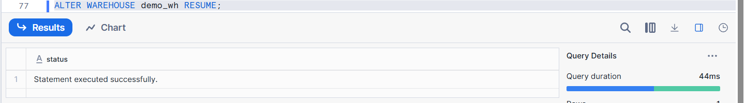
Run the Query :
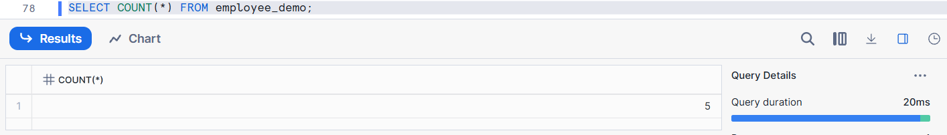
Result :
Query runs slower than result cache
Faster than first-ever execution
Data is fetched from Remote Cache → Local Disk Cache

7. Explain Result Cache.
Result Cache stores the final output of a query so that when the same query is executed again, Snowflake can return the result without re-executing the query. Result Cache gives the fastest query response.
Key Points
- Stored in the Cloud Services layer
- Does not use warehouse compute
- Valid for 24 hours
Practical:
Run a COUNT(*) query twice and note that the second run doesn’t consume compute resources.
First Time:
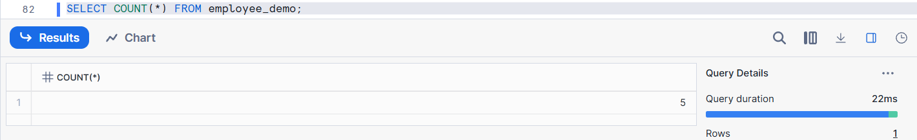
Second Time:
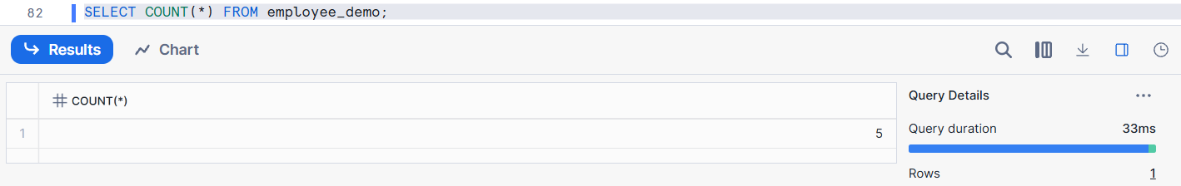


8. How does Local Disk Cache differ from Result Cache?
Result Cache :
- Stores the final query result
- Stored in Cloud Services layer
- No warehouse compute is used
- Valid for 24 hours
- Used only when the same query is rerun without data changes
Local Disk Cache
- Stores raw data blocks (micro-partitions) on the warehouse’s local SSD
- Warehouse compute is required
- Cache is per warehouse
- Cleared when the warehouse is suspended or resized
Practical:
Run a query, suspend warehouse, restart it, run the query again, and observe performance change.
Run a Query :
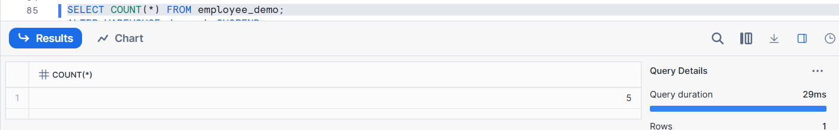
Query runs normally
Data loaded into Local Disk Cache
Warehouse Suspended :

Warehouse stops
Local Disk Cache is cleared
Resume The warehouse
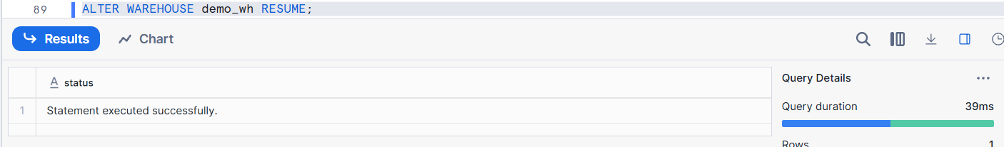
Run this Query Again :
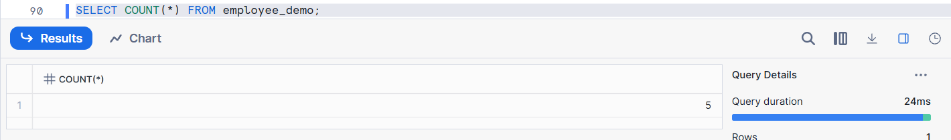
Query runs slower than result cache
Data must be read again from Snowflake storage
Local Disk Cache is rebuilt

9. What happens to caches when table data changes?
Result Cache
Immediately invalidated when:
- INSERT
- UPDATE
- DELETE
- MERGE
Because the final result may no longer be correct
Next query must be re-executed
Local Disk Cache
NOT invalidated when data changes
Still holds older data blocks
Snowflake intelligently:
- Reads new micro-partitions from storage
- Uses cached blocks where valid
Remote (Storage) Cache
Always contains the latest data
Source of truth
Practical:
Run a query twice, insert new rows, run again and explain why the Result Cache is invalidated and query runs fresh.
Runs Query First Time
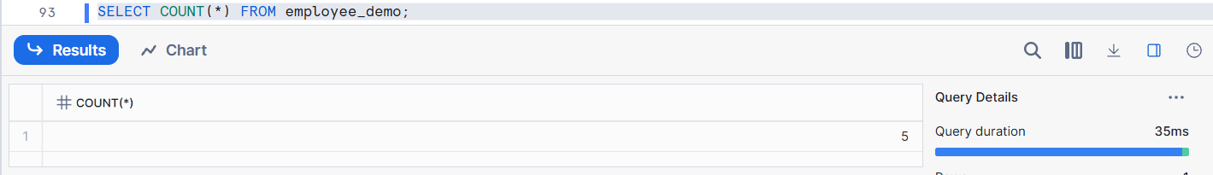
Runs Query Again
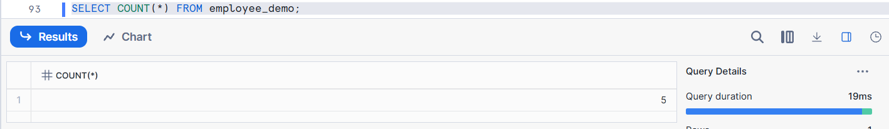
Insert Two Rows :
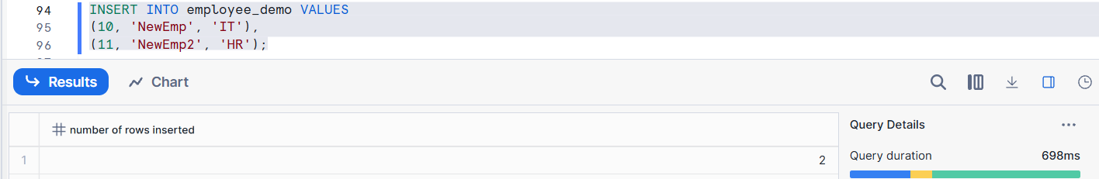
Run Query
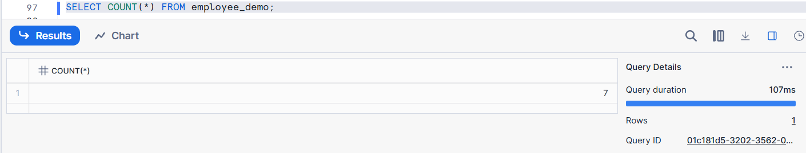
Query executes again using compute
Result cache is NOT reused
Count value changes

10. Describe the difference between first and second run of the same query.
First Run of the Query
- Query is parsed and optimized by Cloud Services
- Virtual Warehouse compute is used
- Data is read from:
  - Local Disk Cache (if available) or
  - Snowflake Storage layer
- Query takes more execution time
- Result is stored in Result Cache
Second Run of the Same Query
- Snowflake finds the same query result in Result Cache
- No warehouse compute is used
- Query returns almost instantly
- Execution time is very low
Practical:
Run a query once (full compute), then immediately run again (Result Cache), and explain the difference in resource usage.

Again run it


During the first execution, Snowflake used the virtual warehouse to process the query and stored the result in the Result Cache. During the second execution, Snowflake reused the cached result, so no compute resources were consumed.

11. How does Snowflake’s compute scaling work?
Snowflake’s compute scaling works by allowing Virtual Warehouses to be:
- Scaled up (XS → S → M → L → XL) to add more CPU and memory
- Scaled down when less power is needed
- Started / Stopped independently from storage
Key Points
- Scaling is instant and online (no downtime)
- Storage is not affected
- Larger warehouses:
  - Process more data in parallel
  - Execute complex queries faster
- Users pay only for compute usage time
Practical:
Run a complex query on a small warehouse, then increase warehouse size and rerun the query, observing improved speed.
Create small warehouse
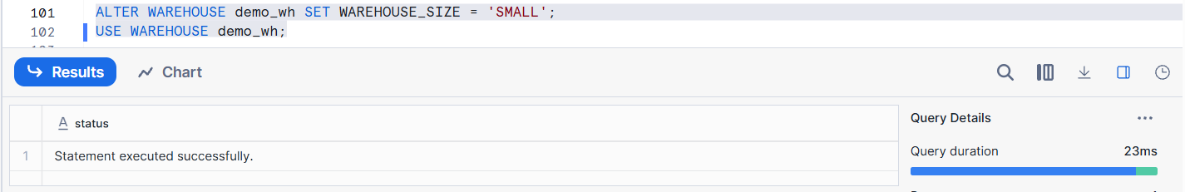
Run a complex query
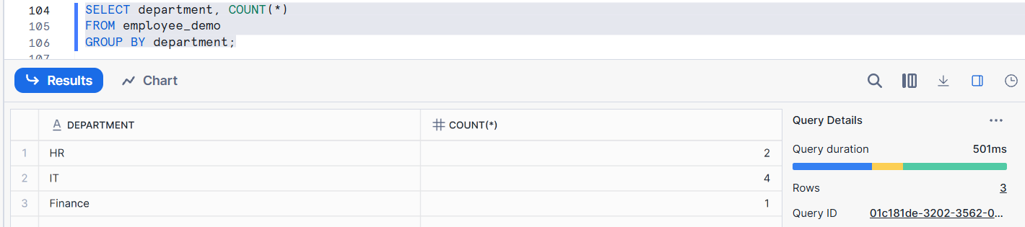
Warehouse Size to Medium
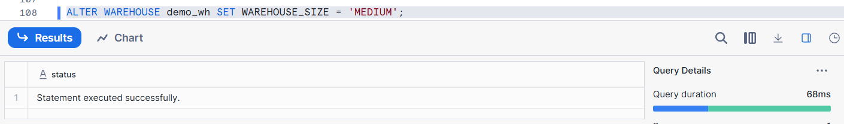
Run the same query again
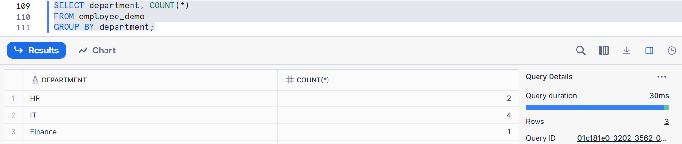
When the warehouse size was increased from Small to Medium, Snowflake allocated more compute resources. This improved query performance by allowing greater parallel processing of data.

12. Explain external stage vs internal stage.
Internal Stage
An Internal Stage is a Snowflake-managed storage location used to temporarily store files inside Snowflake.
Key Points:
- Managed completely by Snowflake
- No cloud account (S3/Azure/GCP) needed
- Used for:
  - Small to medium data loads
  - Testing and demos
- Data is stored inside Snowflake account
External Stage
An External Stage points to data stored outside Snowflake, such as AWS S3, Azure Blob, or GCS.
Key Points:
- Data remains outside Snowflake
- Requires:
  - Storage integration
  - Cloud permissions
- Used for:
  - Large datasets
  - Continuous ingestion
- Snowflake only reads the data, it does not store it internally
An internal stage stores data inside Snowflake, while an external stage references data stored in external cloud storage like S3.
Practical:
Create an internal stage and upload a file. Create an external stage pointing to S3 and explain the differences.
Create Internal Stage & Upload File
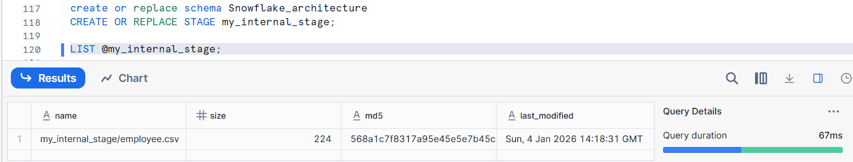
Create External Stage
Storage Integration
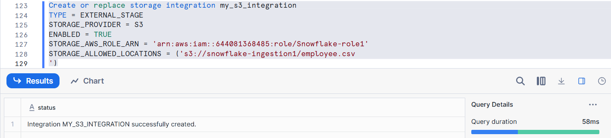
EXTERNAL STAGE
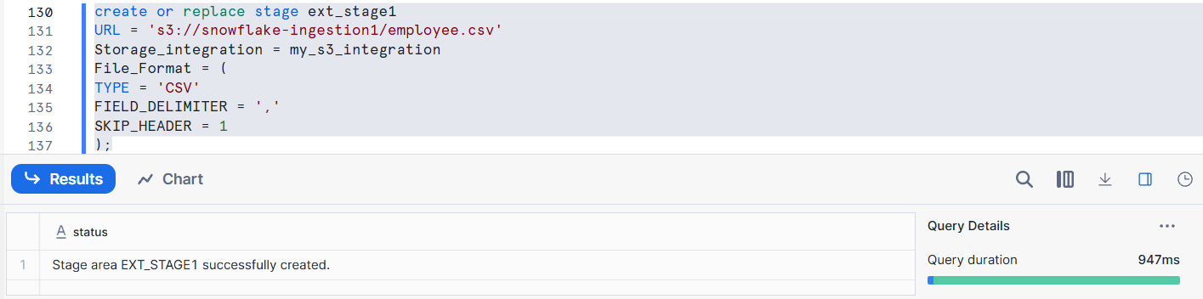
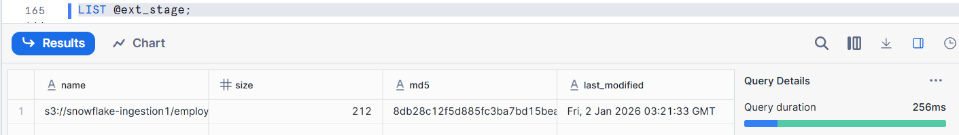
Internal stages are Snowflake-managed storage locations, whereas external stages allow Snowflake to access data directly from external cloud storage like S3.

13. Explain the statement:
“Data never moves, compute comes and goes.”
Data is stored permanently in the Snowflake Storage layer
- Compute (Virtual Warehouses) are:
  - Started when needed
  - Suspended when not in use
  - Resized anytime
- Data is NOT affected by any warehouse action
Snowflake separates storage and compute.
Practical:
Show data stored in table remains the same regardless of warehouse start/stop and resizing.
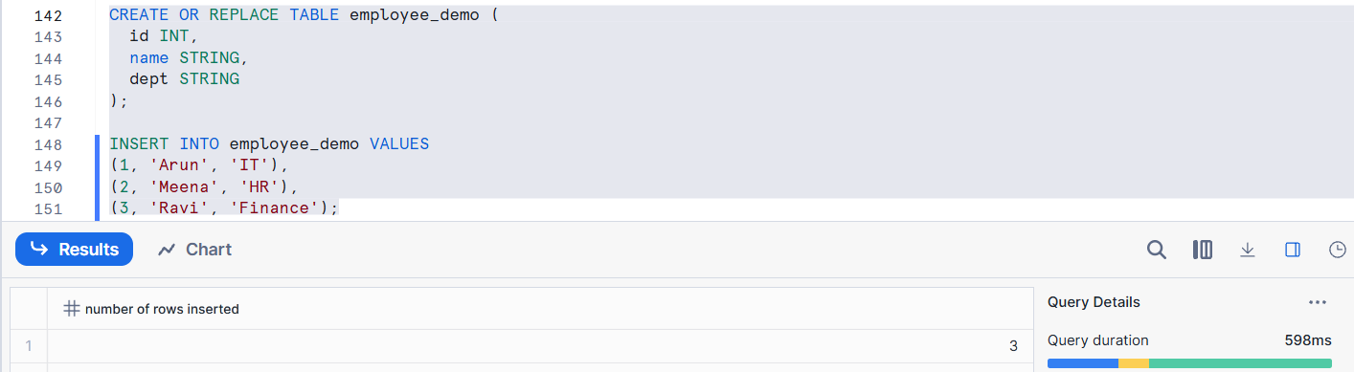
Run Query

Suspend Warehouse
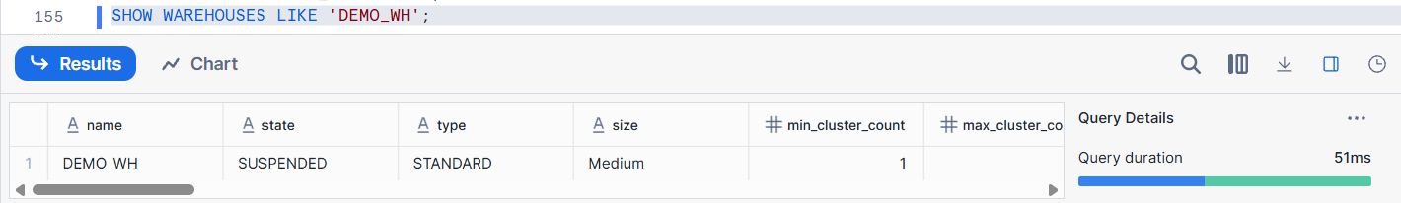
Resume Warehouse
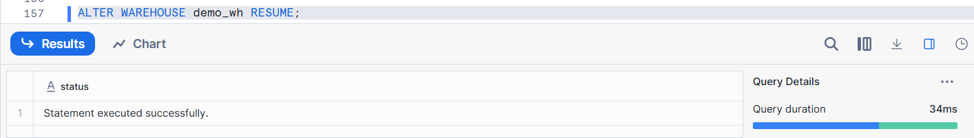
Query Again
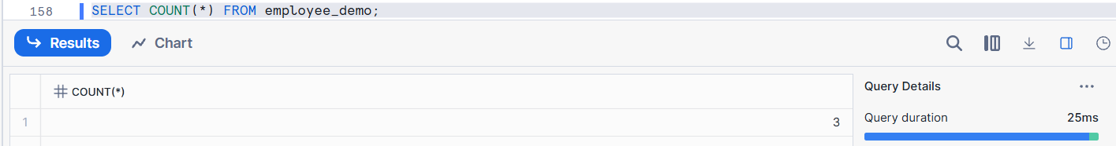
Resize warehouse
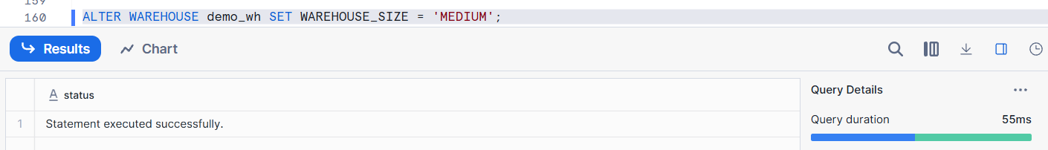
Query after resizing
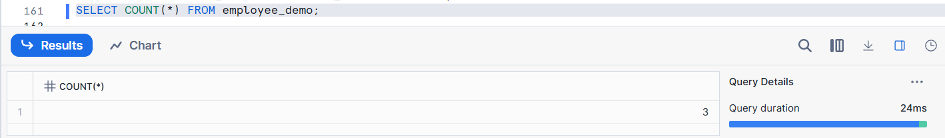

14. Will Snowflake use Result Cache with non-deterministic functions like CURRENT_DATE? Why?
No. Snowflake does NOT use Result Cache for queries that contain non-deterministic functions like CURRENT_DATE, CURRENT_TIMESTAMP, RANDOM(), etc.
Why Result Cache Is Not Used
- Result Cache stores query results
- It can only be reused when the result is guaranteed to be the same
- Non-deterministic functions:
  - Return different values over time
  - Results are not predictable
So Snowflake re-executes the query every time
Practical:
Run a query with CURRENT_DATE, run it again, and show Result Cache is not used.
Run a query with CURRENT_DATE
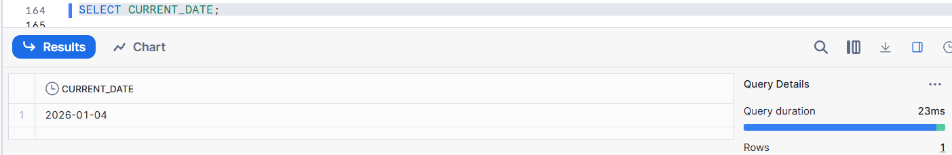
Run it again
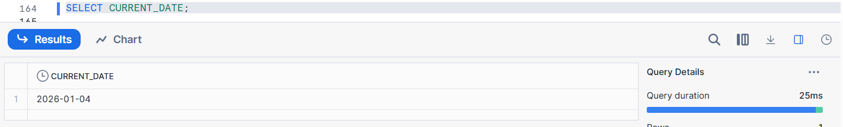
Query executes again
Result Cache is NOT used

15. Summarize how Snowflake optimizes cost through architecture and caching.
Architecture-Based Cost Optimization
Snowflake uses a separation of storage and compute, which allows cost control:
- Storage layer stores data permanently and cheaply
- Compute layer (Virtual Warehouses) runs only when queries execute
- Warehouses can be:
  - Started on demand
  - Suspended when idle
  - Resized based on workload
Users pay only for compute time used, not for idle resources.
Caching-Based Cost Optimization
Snowflake uses three levels of caching to reduce compute usage:
- Result Cache
  - Reuses previous query results
  - No compute cost
  - Fastest execution
- Local Disk Cache
  - Data cached on warehouse local disk
  - Reduces storage reads
- Metadata Cache
  - Optimizes query planning and pruning
Practical:
Explain how suspending warehouses when idle and reusing Result Cache save money.
Warehouse Suspended
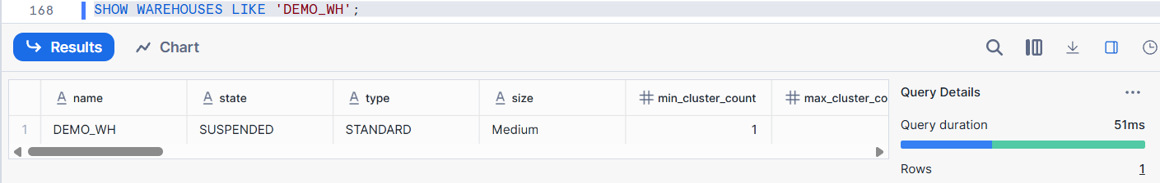
Run a Query
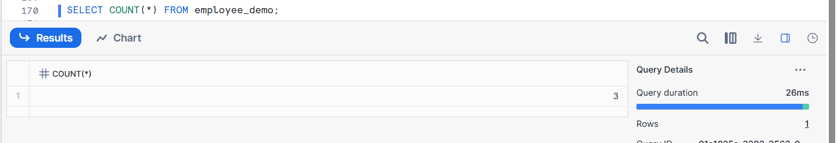
Run the same query again
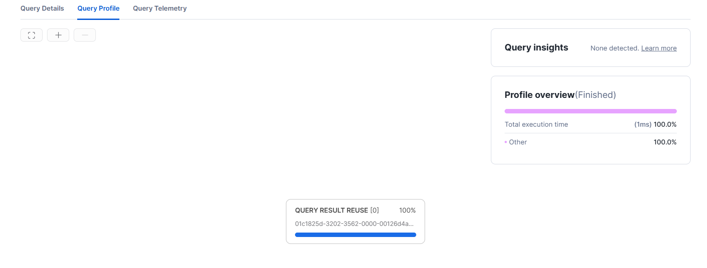
Query profile shows QUERY RESULT REUSE = 100%
No warehouse usage
Execution is instantaneous
Snowflake optimizes cost by separating storage and compute and by using caching mechanisms that reduce repeated computation.

